Quorum Consensus Protocol - Distributed Lock Manager Concurrency Control

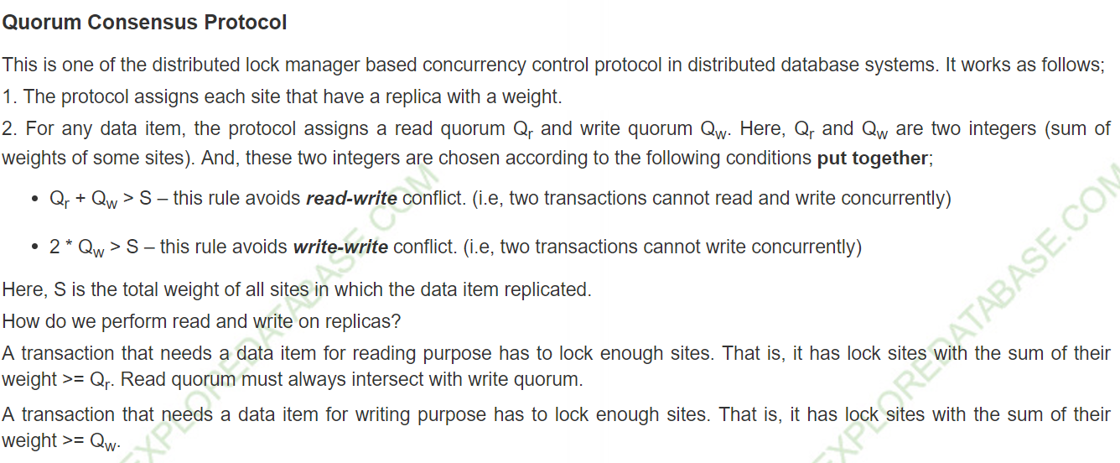

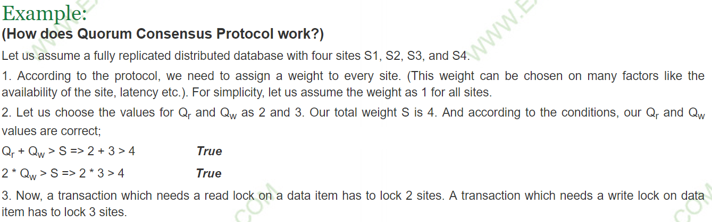

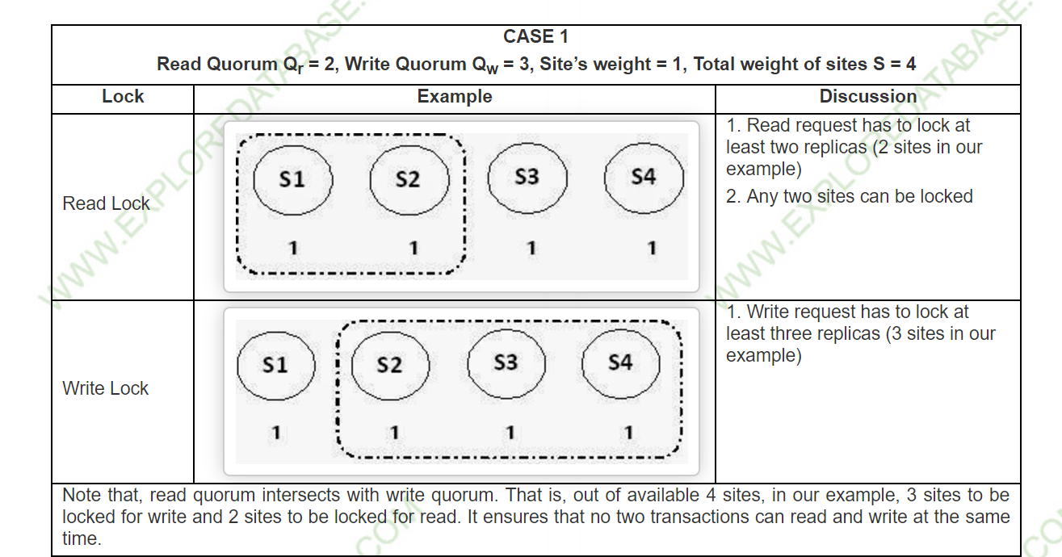

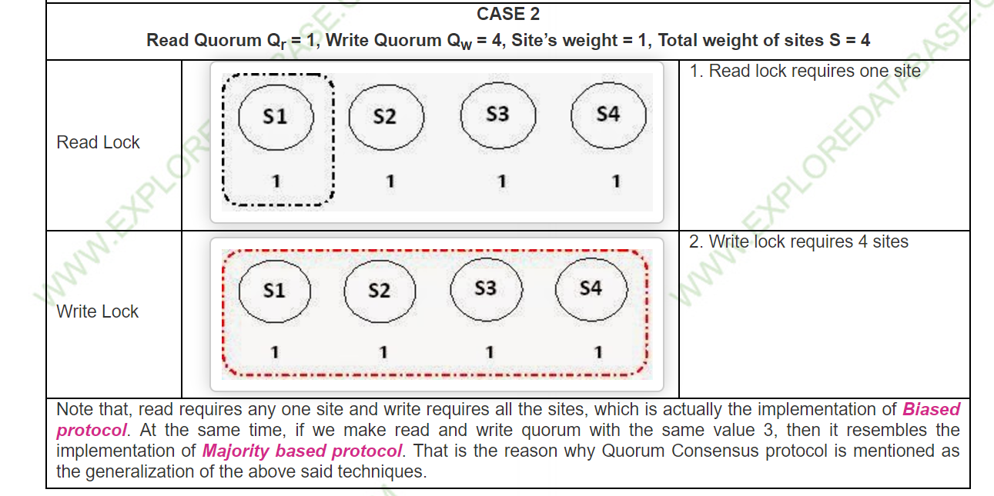

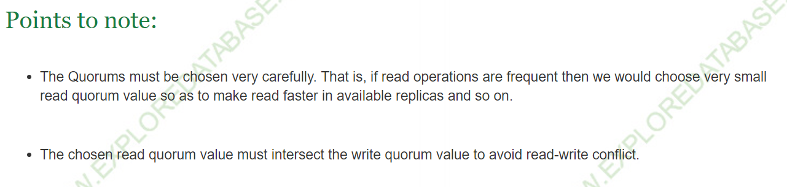

<http://www.exploredatabase.com/2014/04/quorum-consensus-protocol-distributed.html>